Use-Case Realization Report
UpdateRole

Issue <1.0>
Revision History
Date | Issue | Description | Author
<02/08/09> | <1.0> | <Update Role> | <Karen Gao>

Table of Contents
1. Brief Description 4
2. Flow of Events 4
2.1 Standard Flow 4
2.2 Exceptions 4
3. Interaction Diagrams 5
3.1 Collaboration Diagram for UpdateRole 5
4. Participating Objects 5
5. Class Diagrams 6
5.1 Class Diagram for UpdateRole 6
6. Derived Requirements 6

Use-Case Realization Report
UpdateRole

Brief Description
The update of Role shall be executed once the selection check for the existing Role list was performed.

Flow of Events

Standard Flow
This use case covers the events of updating Role, which is part of the Maintenance Role package. The standard flow of events is described as below:
- The Portal Administrator shall press the button to send out a command of “updateButtonClicked” on the interface of MaintainRolePage.
- Once MaintainRoleController received this request, the operation checkRoleToUpdate will check if there’s Role seleted.
- Then the operation getDapList will get the Dap List from object of Dap, and show to the MaintainRolePage through the operation showDapList.
- The operation selectDap will select the Dap for the Role
- Subsequently, the operation getFapList will get the Fap List from object of Fap, and show to the MaintainRolePage through the operation showFapList.
- The operation selectFap will select the Fap for the Role
- The role then updated and then the operation updateRoleList of the MaintainRoleController will update the new list of Role object
- Once it’s done, the successful updating Role will show to the MaintainRolePage.

Exceptions

- If there’s no selection found in Role records, a warning message will be show to the MaintainRolePage through the operation showNoRoleSelectedMsg.

Interaction Diagrams

Collaboration Diagram for UpdateRole
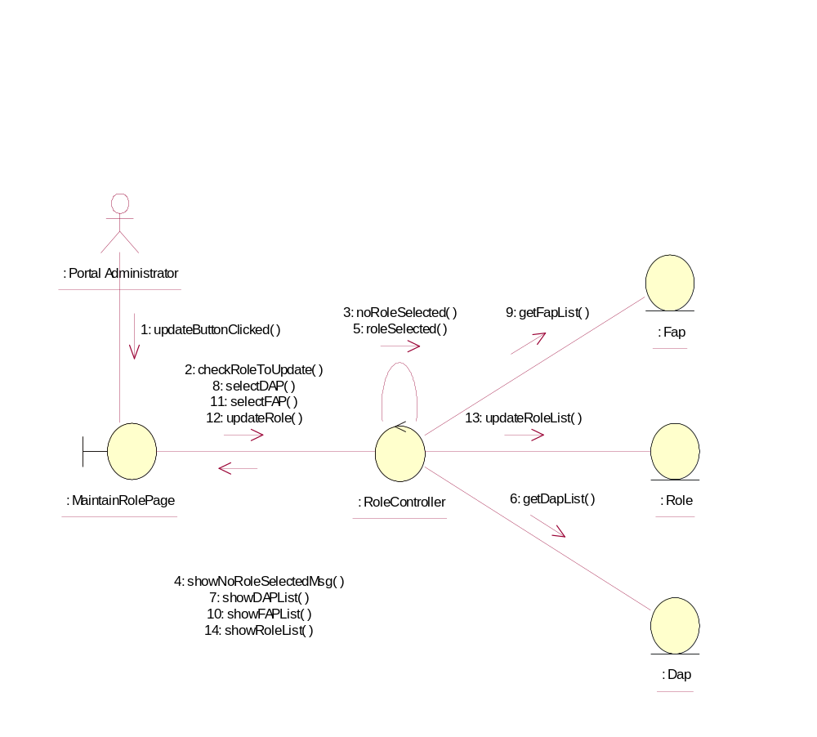

Participating Objects
: Dap
This Entity is Dap object

: Fap
This Entity is Fap object

: MaintainRolePage
This is a page for adding, deleting, updating and displaying Role

: Portal Administrator
This is the super user of the system.

: Role
This Entity is Role object

: RoleController
This controller is to add, delete and update Role

Class Diagrams

Class Diagram for UpdateRole
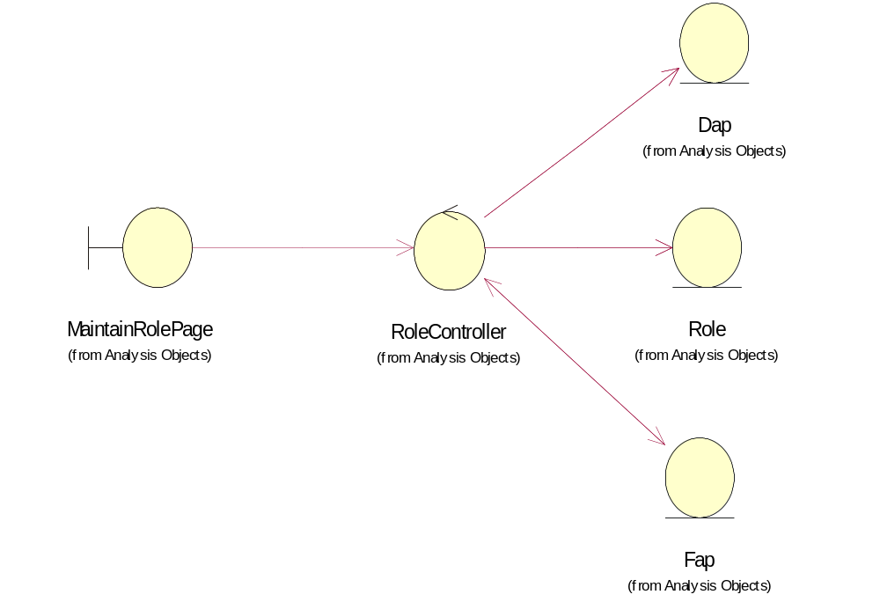

Derived Requirements
Only Portal Administrator has rights to access this page

